Chapter 7 Linear motion
Chapter test Total marks 46
Name: ______________________________ Class: ____________ Date: _______________
Section A (2 marks each)
Question 1
In the study of motion, which of the following gives the best definition of displacement?
A how far a body travels
B the change in position of a body in a given direction
C the location of an object as taken from a certain direction
D the distance travelled by an object that is moving in a straight line
Question 2
In 2011, Ivo Karlovic from Croatia made the fastest recorded tennis serve in history. His serve had a speed of 251 km h^{–1}. How fast is this in metres per second?
A 6.97 m s^{–1}
B 69.7 m s^{–1}
C 100 m s^{–1}
D 904 m s^{–1}
Question 3
A super-bouncy ball hits a wall with a velocity of 7.0 m s^{–1} east and rebounds with a velocity of 6.0 m s^{–1} west. Determine the change in velocity of the ball.
A 1 m s^{–1} west
B 13 m s^{–1} east
C 13 m s^{–1} west
D 1 m s^{–1} east

The following information relates to questions 4–7.
The graph below shows the displacement of a farmer on a motorcycle, riding to and fro along a boundary of his property while counting livestock.

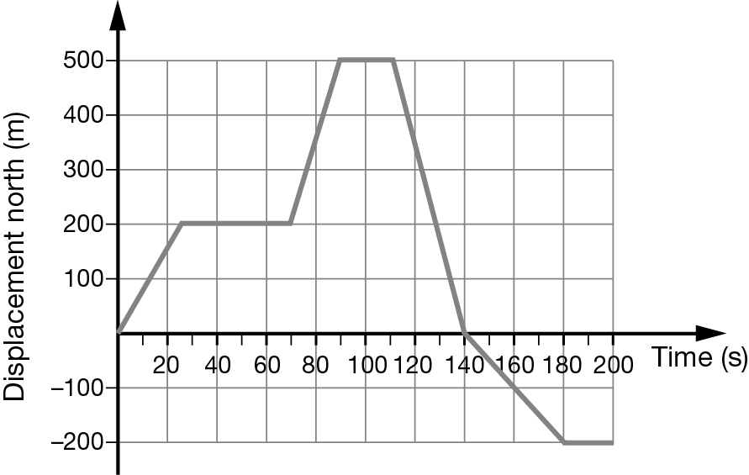
Question 4
How far did the farmer travel during the first minute?
A 60 m
B 9000 m
C 200 m
D 6.7 m
Question 5
Which of the following describes the motion of the farmer at t = 120 s?
A stationary
B heading forwards with a speed of 17 m s^{–1}
C decelerating
D returning back with a speed of 17 m s^{–1}
Question 6
What was the total distance travelled by the farmer over the entire period?
A 500 m
B 300 m
C 700 m
D 1200 m
Question 7
What was the average velocity of the farmer during the last 60 s of his journey?
A south 3.3 m s^{–1}
B south 4.0 m s^{–1}
C 0 m s^{–1}
D south 18 m s^{–1}
Question 8
A ball rolls down a ramp with uniform acceleration. It starts from rest and is travelling at 0.8 m s^{–1} when it reaches the bottom of the ramp 5 s later. Which equation should be used to determine its acceleration?
A
B
C
D
Section B
Question 9
A car reaches a speed of 72 km h^{–1}, from rest, in a time interval of 5.0 s.
a What was the average acceleration of the car in metres per second? (2 marks)

b The car then maintains this speed for 15 s. How far is it from its starting position at the end of the 15 s? (3 marks)

c The car now decelerates uniformly at a rate of 4.0 m s^{–2}, until it comes to a stop. On the axes provided, draw the velocity–time graph for the car’s entire journey. (3 marks)

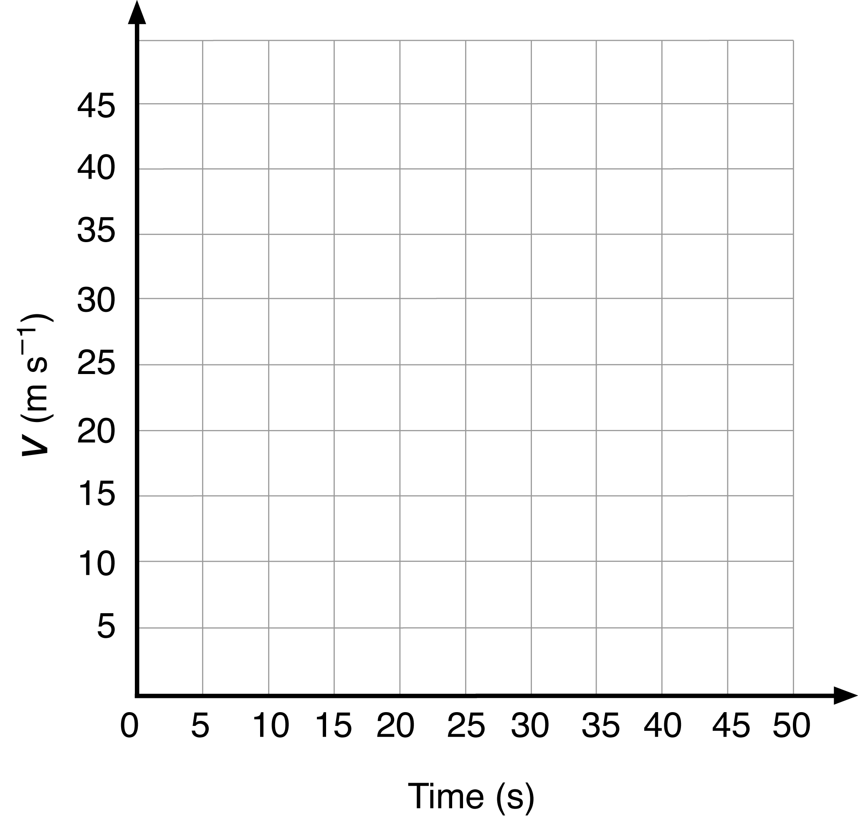

d Calculate the average velocity of the car during its entire journey. (2 marks)

Question 10
A cyclist rides 1.50 km east along a straight path at 27.0 km h⁻¹ before she suddenly notices a ‘path closed’ sign ahead, causing her to stop.
a What is the cyclist’s initial speed in m s⁻¹? (1 marks)

b If she takes 0.590 s to react to the sign, what distance does she travel before braking? (2 marks)

c Once she pulls on her brakes, the cyclist decelerates at 2.50 m s⁻². How far does she travel while coming to rest? (2 marks)

d What total distance does the cyclist travel from the time she first notices the ‘path closed’ sign to when she comes to a stop? (1 mark)

Question 11
An archer fires an arrow vertically into the air from ground level at a speed of 20.0 m s^{–1}. Ignore the effects of air resistance.
a What is the initial vertical acceleration of the arrow? (1 mark)

b For how long will the arrow be in the air? (2 marks)

c What is the acceleration of the arrow at the top of its flight? (1 mark)

d What is the maximum height the arrow will reach? (2 marks)

e What is the speed of the arrow just before it hits the ground? (1 mark)

Question 12
A stone is thrown upwards at 30.0 m s^{–1} from the top of a cliff and lands in the sea 40.0 m below. Ignore the effects of air resistance.
a Calculate the speed of the stone when it hits the sea below. (3 marks)

b Determine the total time the stone was moving in the air. (2 marks)

c How far above the sea did the stone reach? (2 marks)

